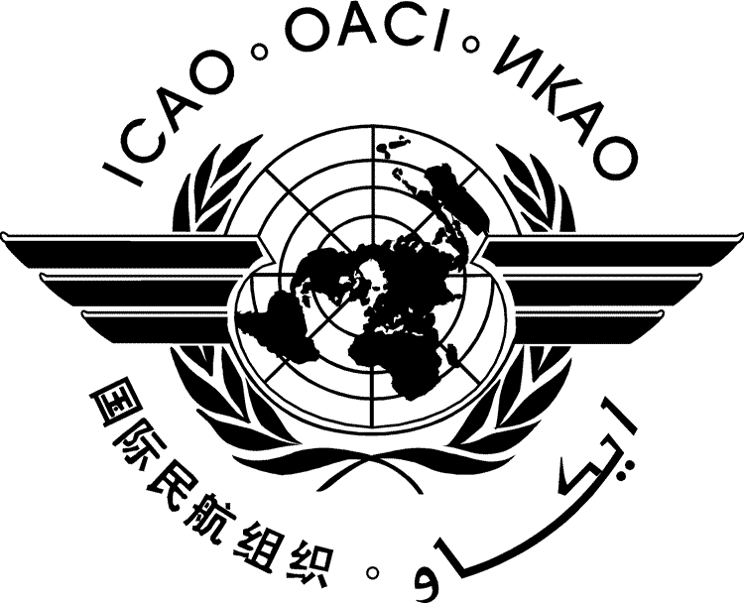 | International Civil Aviation Organization  WORKING PAPER | METP-WG/MOG/1-WP/xxxx  ../../15
MEETING OF THE METEOROLOGY PANEL (METP)
WORKING GROUP MOG

FIRST MEETING

Gatwick, London, United Kingdom, 8 to 11 September 2015

Agenda Item | ?: | Agenda item title
 | ?.?: | Sub-agenda item title

TITLE

SUMMARY
Action by the METP-WG/MOG is in paragraph ‎2.

- INTRODUCTION
  - ...
- ACTION BY THE METP-WG/MOG
  - The METP-WG/MOG is invited to:

